**DESIGN DETAILS**

Messenger robot 1 is a semi-autonomous robot. It travels from *Khangai Urtuu* to *Line 1 of Khangai Area* autonomously using the LSA08 line following sensor module for feedback. This decision was taken to reduce human error and make the locomotion efficient. The commands for *Shagai* lifting, *Shagai* throwing and *Gerege* transfer are sent by the PS3 remote to the microcontroller via the USB Host Shield. Since the arena of red and blue team is mirror image of each other, MR1 is made symmetrical about its central axis so that it can adapt to both sides.

MR2, on the other hand, is a completely autonomous quadruped robot that employs image processing-based path tracking algorithms and self-balancing corrections with respect to the structural mechanics for navigation throughout the assigned arena.

**MESSENGER ROBOT 1**

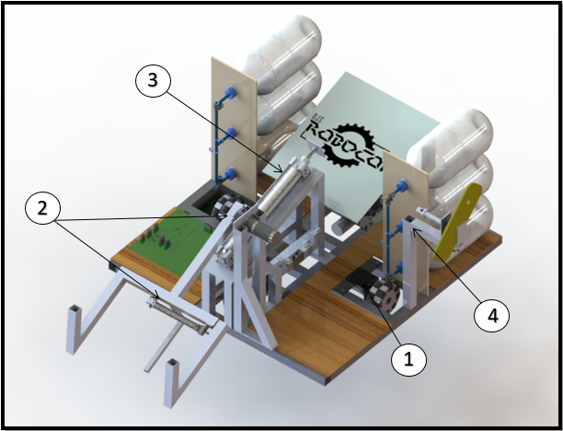

1. **TYPE OF DRIVE**

The Messenger Robot 1 has a plus-holonomic drive wherein 4 planetary geared DC motors each having a power rating of 100W and peak speed of 41.89 rad/sec (450 RPM). This type of drive uses Omni directional wheels for minimizing the drag generated due to varying speed and hence provide seamless and effective locomotion. The wheels are placed within the outer edge of the base frame so that they are protected from any external damage. This also minimizes the overall dimension of the robot thereby making it more agile and allowing ease of movement through the forest area.

1. **PICKING AND PLACING MECHANISM**

The *Shagai* is placed near Line 1 having silver side on the top. The *Shagai* picking mechanism employs a gripper with integrated pneumatic actuator. This gripper is mechanically coupled to motor actuator.

1. Mass of gripper mechanism = mass of {pneumatic actuator + link mass + *Shagai* + couplings} ≈ 1 kg
2. Gripper arm length = 0.4m
3. Required torque for motor actuator to lift mechanism at pivoted end = 4 Nm

Motor parameters → 12v, 100 Watt, planetary geared, 2 rad/s max speed (includes buffer torque)

Throwing platform is inclined at an elevation of 18° approx. On actuation, the motor rotates link, accurately placing the *Shagai* on the throwing platform. The inclination in the platform facilitates in proper landing of the *Shagai* (Golden side upwards).

Pneumatic piston specifications: 100mm, 16mm Ø, 72N output force (4 bars) double acting miniature cylinder for picking of the *Shagai*.

1. **THROWING MECHANISM**

The throwing mechanism makes use of a double acting pneumatic actuator. The pneumatic actuator is mounted on an aluminium frame which is kept at the same inclination as the platform. The point of contact lies on the centroidal axis so that maximum force is transferred to the *Shagai* and its angular deviation is minimized. After performing drag analysis on STAR-CCM+, it was decided that the impact lies on the bigger arc giving an aerodynamic advantage.

Pneumatic piston specification: 250mm, Ø32mm, 434N output force (6 bars) double acting Cylinder for launching the *Shagai*.This cylinder, coupled with Quick exhaust valves provides maximum acceleration which can throw the *Shagai* as far as 3 meters.

1. **GEREGE HOLDING AND PASSING MECHANISM**

Abiding to the rules, *Gerege* is placed at a height such that the top of the *Gerege* is above the main body of MR1. A pneumatic piston is used for gripping the *Gerege* firmly. A provision is given to rotate the holding mechanism in horizontal plane using a servo motor so that the *Gerege* is always aligned in the plane perpendicular to the motion of the MR1. This also facilitates the easy transfer of *Gerege* to MR2.

Pneumatic piston specification: 25mm, Ø12mm spring return cylinder.

**MOTORS USED:**

|  |  |  |  |  |  |  |  |
| --- | --- | --- | --- | --- | --- | --- | --- |
| Sr.  No | Motor Model | No. of Motors | Rated Torque (Kgfcm) | No-load current (A) | Full Load current (A) | Operating voltage in voltage(rated voltage) | RPM |
| 1. | Planetary DC Geared Motors (Base driving) | 4 | 35 | 1.2 | 4 | 12 | 450 |
| 2. | Planetary DC Geared Motors (Gripper) | 1 | 70 | 2.2 | 6.5 | 12 | 150 |
| 3. | MG996 Metal Gear Servo Motor | 1 | 15 | 0.36 | 1.45 | 4.8 - 7.2 | --- |

**Load Calculation:**

$$Calculate Load= \sum{\left(Continous Current Consumption ×No. of motors\right)}$$

$$=\left(2.8 ×4\right)+\left(3 ×1\right)+ \left(0.56 ×1\right)$$

$=14.76 A$

**Battery Calculations: $$Total Load=14.76 A$$**

$Working Hours=20 min$ (considering time of practise sessions)

$$Battery Capacity=Load ×Hours$$

$=14.76 ×0.34$

$=4.92 Ah$

**Battery Used**: 5500mAh 3S/25C

**ELECTRONIC AND PNEUMATIC COMPONENTS:**

**Torque Calculation:**

Weight of the bot = 12kg

Number of motors = 2 (at a time only two motors rotate)

Normal reaction force on each motor (N) = 12*9.81/2

= 58.86N

$∴$ Torque = Force*Radius of wheel

Frictional force to overcome = µN

Assuming µ = 1;

F = 1*58.86 = 58.86;

Torque = 58.86*0.05 = 2.943 Nm = 29.43 Kgfcm

Considering factor of safety, motor with **35 kg-cm** torque were chosen.

|  |  |  |  |  |  |
| --- | --- | --- | --- | --- | --- |
| Sr. No. | Model Name | No. of components | Operating Voltage (V) | Current required (A) | Purpose |
| 1. | Arduino Due | 1 | 3.3V  Input voltage = 7-12V | -- | Processing unit |
| 2. | Pneumatic Pressure Regulating Valve  (Festo VPPE-3-1-1/8) | 1 | 24V | 0.15 | Major factors affecting accurate landing of *Shagai:* Weight of *Shagai* (600-800gm), Material, Shape. This change is compensated by changing the force output which is achieved by varying pressure through PRV using dynamic programming. The *Shagai* gripper and the launching piston has a common reservoir. Thus, to meet the different objectives of MR1 as well as to achieve maximum efficiency, pressure regulating valve is used. |
| 3. | Pneumatic Directional Control Valve | 3  (2 - 5/3  1-3/2) | 12V | 0.8 | The valve used for actuating the cylinders on the bot. There are 3 DCVs mounted on the bot. A 3/2 solenoidal actuated DCV is used to control a single acting spring return cylinder used for *Gerege* holding. For controlling two double actuating cylinders, 5/3 solenoidal actuated DCVs are used for gripping and throwing of *Shagai*. |
| 4. | LSA08  (Line Following Sensor) | 2 | 12V | 0.02 | The task of moving from the Forest Area up to the Line 1 is achieved by following the white line using LSA08 sensor. Auto calibration feature of LSA08 calibrates the sensor to the line and background surface easily. LSA08 can be used in 3 different modes, i.e. digital mode, serial mode or analog mode, and hence provides flexibility in selecting the interfacing with the controller. |

**Load Calculations**

Working hours: Max. 30 minutes (considering time of practise sessions)

Calculated load = (0.15*1) + (1*3) + (0.03*2)

                        = **3.21 A**

**Battery Calculations**

Battery Capacity = Load * Hours

                       = 3.21A * 0.5h

                          ≈ **2Ah**

**Battery Used:** 3300mAh 3S/20C (Lithium Polymer)

**MESSENGER ROBOT 2**

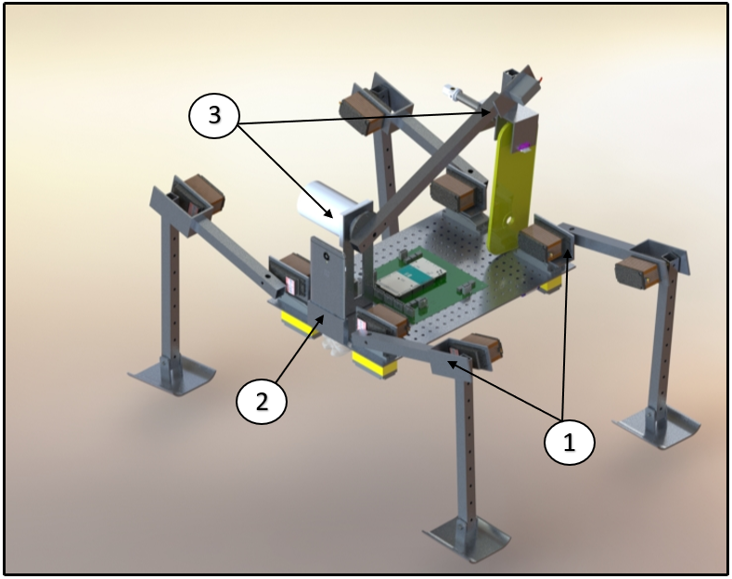

The Messenger Robot 2 perceives its surroundings with the help of image processing. Considering advantages of both, a mammalian quadruped and a hexapod, an optimal solution to the given theme was designed.

An android device mounted on the robot is used to capture the image at a higher resolution, compute the algorithm using self-developed application and then send the control signals to the microcontroller via Bluetooth which makes the robot respond accordingly. Sensors such as Gyroscope and Accelerometer available in the android devise, are used for providing feedback for balancing the robot.

1. **MR2 DRIVE MECHANISM**

The MR2 consists of four legs, each leg having 3 revolute joints and 3 degrees of freedom which gives us considerable freedom for movement as well as correction. The actuators are servo motors which are selected after detailed analysis and calculations. The knee, shoulder and hip joints are actuated in different sequences for walking, turning right, left and climbing the mountain as well as crossing the sand dune and tussock.

The highlight of the MR2 problem statement was in choosing the appropriate gait for locomotion. After testing the dynamic stability of the robot in different gaits, walk and trot gait was selected.

1. **MR2 DRIVE MECHANISM (CONTROLLING)**

MR2 is simulated in MathWorks Simulink using *Simscape Multibody* and *Simscape Electrical* Libraries to test the initial conditions under gravity. Path planning algorithm is verified using forward kinematics and the required angles for the displacement are found by inverse kinematics. The actuation to the joints of the MR2 is provided by ‘Torque’ method and the input is provided by the Servo subsystem modelled using Simulink blocks.Various movements are defined using *Stateflow Chart* to tackle different obstacles in MR2’s path.

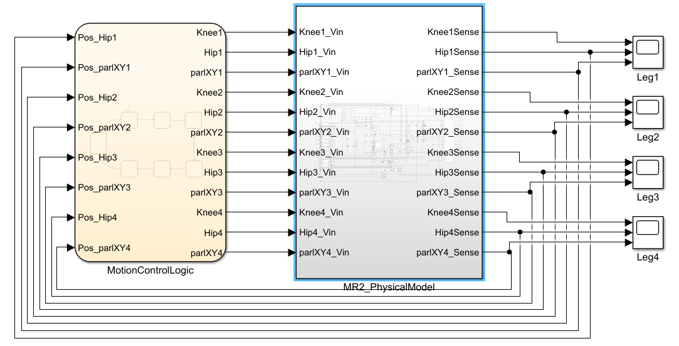

MR2 sensing and navigation is divided into 2 parts:

1.      White Line detection

2.      Sand dune and Tussock detection

**White Line Detection:**

The camera captures the images of arena with a pixel resolution of 1920x1080p. The light sensor besides the camera senses the intensity of light. If the intensity of light is within the tuned values, the captured image is further processed. The RGB captured image is converted into the HSV colour space for noise reduction. The *Colour Thresholding* app of MATLAB is used to separate out the white colour from the remaining colours and a highly contrast BW image is obtained as output. Dedicated functions including *bwAreaOpen* and ***imfill***of *Image Processing and Computer Vision Toolbox* are used to reduce noise from the output image.

***Sand Dune* and *Tussock* Detection:**

Colour detection technique is used to identify *Sand Dune* and *Tussock* regions. As the robot approaches these regions, more and more pixels will be detected, and a value is set at which MR2 take the required action to cross the *Sand dune* or *Tussock*.

This algorithm is deployed on hardware using *Arduino Hardware Support Package* and *Android Hardware Support Package.*

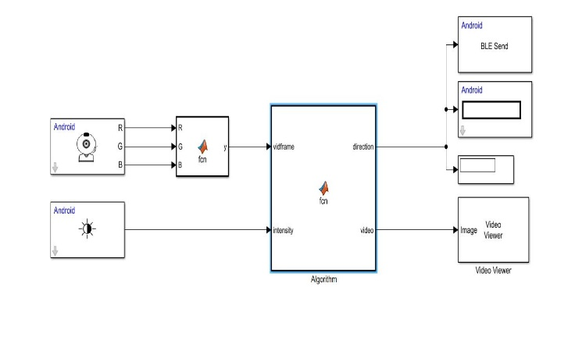

1. **GEREGE HOLDING AND RAISING MECHANISM**

Gerege holding and raising mechanism employs a pneumatic system for gripping of the Gerege and a DC servo motor for raising it. The gripper consists of 2 arms, one being stationary while other is connected to the rod end of the miniature cylinder, which actuates it, hence, providing gripping action. The gripper is set on the same height of the Gerege on MR1 to facilitate easy transfer. The gripper is mounted on a servo providing an additional DOF, such that the Gerege is rotated towards the main body thus increasing the dynamic stability of the whole robot and positioning the Gerege below the main body as mentioned in the rule book.

This whole assembly is mounted on a DC servo motor which is used to lift the Gerege to a height of 1m at the mountain top, finally, achieving *Great Urtuu.*

**MOTORS USED:**

|  |  |  |  |  |  |  |
| --- | --- | --- | --- | --- | --- | --- |
| Sr.  No. | Motor Model | No. of Components | Torque (Kgfcm) | No-load current (A) | Full Load current (A) | Operating voltage (V) |
| 1. | Metal Geared Servo Motors  PDI-HV2060MG  (Hip and Shoulder join) | 8 | 48(6V) – 60(7.4V) | 1 | 7.2 | 6-7.4 |
| 2. | Metal Geared Servo Motors  CYS-S8218  (Knee join) | 4 | 36(6V) – 38(7.4V) | 0.8 | 6 | 6-7.4 |
| 3. | DC Servo Motor  RMCS – 2203  (Gripper Arm) | 1 | 35 | 0.5 | 7 | 11-15 |
| 4. | MG996 Metal Gear Servo Motor | 1 | 15 | 0.38 | 0.8 | 4.8 -7.2 |

**Load Calculation:**

Calculated load (for each leg)

= ∑ (Continuous Current Consumption* number of motors)

= 2.8*3

= 8.4 A

**Battery Calculations:**

Workinghours:15 minutes (considering time of practise sessions)

Battery Capacity =Load*Hours

=8.4 * 0.25

                          =2.1Ah  **Battery Used:**  2200mAh 2S/25C

(LiFePo4) for each leg.

**ELECTRONIC AND PNEUMATIC COMPONENTS:**

|  |  |  |  |  |  |
| --- | --- | --- | --- | --- | --- |
| Sr. No. | Model name | No. of components | Operating Voltage (V) | Current Required (A) | Purpose |
| 1. | Arduino Due | 1 | 3.3  Input Voltage  = 7 - 12 | -- | Processing unit. |
| 2. | HC SR04 (Ultrasonic Distance Sensor) | 1 | 5 | 0.015 | Placed on the body to detect a manual obstruction for sending a signal to start climbing the mountain./ Used to trigger the robot to initiate the mountain climbing sequence. |
| 3. | VL53L0X  (Laser Distance Sensor) | 1 | 2.6 - 3.5 | 0.01 | Placed on the arm of the gripper to detect the *Gerege* when passed from MR1 to MR2. |
| 4. | 3/2 Pneumatic Directional Control Valve | 1 | 12 | 0.8 | A 3/2 solenoidal actuated DCV is used to control a single acting spring return cylinder used for *Gerege* holding. |

**MR2 MOTOR TORQUE CALCULATIONS:**

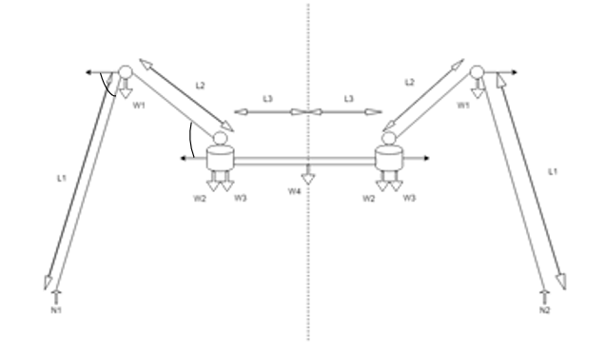

∑Tknee = T1 - N1(L1*cosα) – W2(L2*cosβ) – W3(L2*cosβ) – W4(L2*cosβ + L3) –2W3(L2*cosβ + 2L3) - 2W2(L2*cosβ + 2L3) - 2W1(L2*cosβ + 2L3) + N2(2L2*cosβ + 2L3 + L1*cosα)

∑Thip = T2 - N1(L1*cosα + L2*cosβ) + W1(L2*cosβ) – W4* L3 - 2W2*L3 - 2W3*L3– 2W1(L2*cosβ + 2L3) + 2 N2(L2*cosβ + 2L3 + L1*cosα)